EX.NO: 4
SELECT Queries with WHERE Clause
AIM
To retrieve records from the MobileSales table using the SELECT statement with the WHERE clause.
PROCEDURE
- Select the MobileDB database using the USE command.
- Display all the records from the MobileSales table.
- Retrieve records based on the mobile price using the WHERE clause.
- Retrieve records based on the customer review.
- Retrieve records based on the model year.
- Retrieve records based on the storage capacity.
- Retrieve records using multiple conditions with AND and OR.
- Observe the output of each query.
- Verify that the WHERE clause filters the required records correctly.

COMMANDS

1. Select the Database
USE MobileDB;

2. Display All Records
SELECT * FROM MobileSales;

3. Mobiles with Price Greater Than 30000
SELECT * FROM MobileSales
WHERE Price > 30000;

4. Mobiles with Customer Review Greater Than or Equal to 4.0
SELECT * FROM MobileSales
WHERE CustomerReview >= 4.0;

5. Mobiles Released in 2025
SELECT * FROM MobileSales
WHERE ModelYear = 2025;

6. Mobiles with 256 GB Storage
SELECT * FROM MobileSales
WHERE Storage = 256;

7. Mobiles with Price Less Than 30000 AND Storage = 128
SELECT * FROM MobileSales
WHERE Price < 30000
AND Storage = 128;

8. Mobiles Released in 2026 OR Customer Review Above 4.3
SELECT * FROM MobileSales
WHERE ModelYear = 2026
OR CustomerReview > 4.3;

OUTPUTS
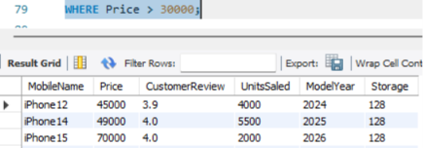

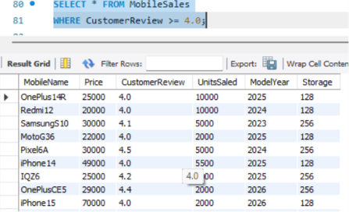

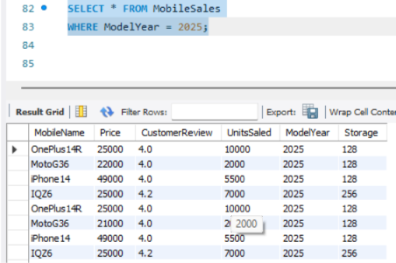

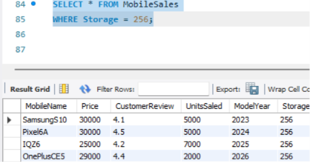

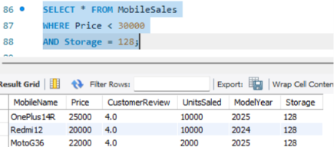

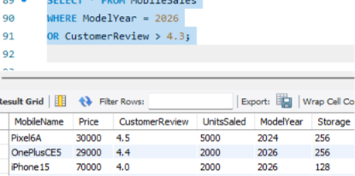
RESULT
Thus, the SELECT statement with the WHERE clause was successfully executed to retrieve the required records from the MobileSales table.

